**Exit Ticket Analysis Report**

**Summary of Student Feedback**

The collected responses from students provide insights into their understanding and engagement with the topic. Below is a summary of the key findings:

**1. Most Interesting Aspects of the Topic**

* Some students mentioned specific areas like "EVS" and "Hindi" as engaging.
* A few responses were unclear, such as "Repeat again," indicating a need for clarification or review.
* Some students appreciated the general knowledge aspect of the lesson.

**2. Clarity of the Topic**

* **60% of students** found the topic clear.
* **40% mentioned they understood but required further reading** to fully grasp the concepts.

**3. Suggestions for Classroom Improvement**

* Most students either had no suggestions or said “Nothing.”
* A few students suggested improvements but did not specify what changes they would like to see.

**Key Takeaways and Recommendations**

1. **Reinforcement Required**: Since some students requested additional reading or repetition, consider summarizing key points in the next session.
2. **Clarification on Feedback**: Encourage students to provide specific suggestions for improvement rather than vague responses.
3. **Interactive Learning**: Implement more engaging activities (discussions, quizzes) to make the lesson more interactive and ensure understanding.

Would you like a more detailed statistical breakdown or visual representation of this data? ​​

4o

**You said:**

yes

**ChatGPT said:**

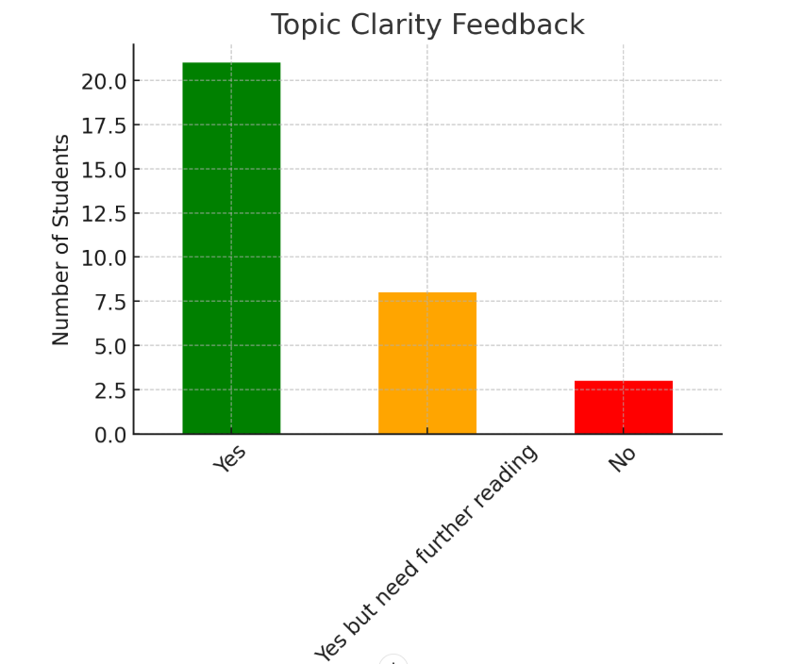

Exit Ticket link:

<https://forms.gle/BaaTtiFVZdn4MoJx7>